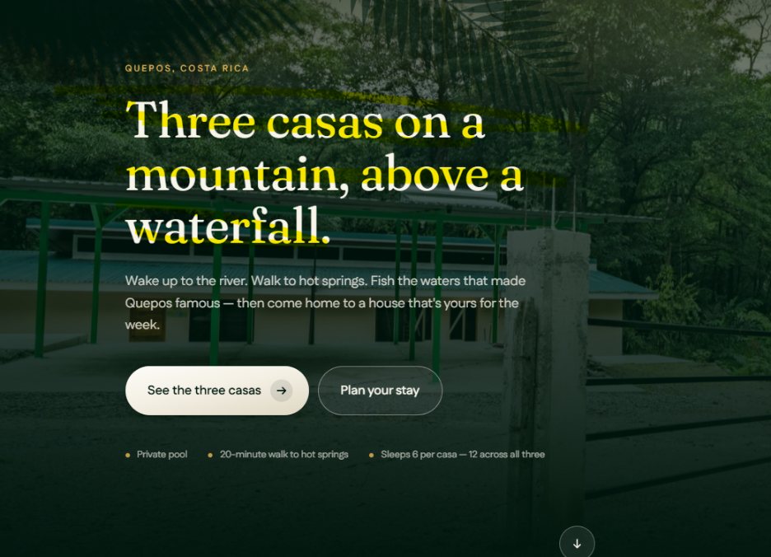
Please change background picture to picture of waterfall
Bottom description change to:
Enjoy a cup of coffee in front of the waterfall, walk to the hot springs, swim in the river and plan your adventure for the day.
3 Individual Units- sleeps 6 people each
18 people altogether
Title:
Choose your adventure
“instead of Three casas on a mountain above a waterfall”

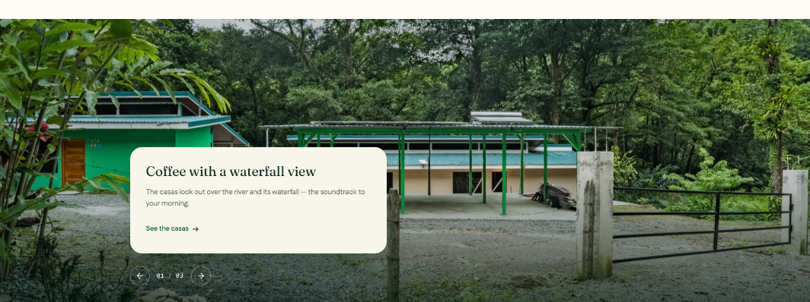

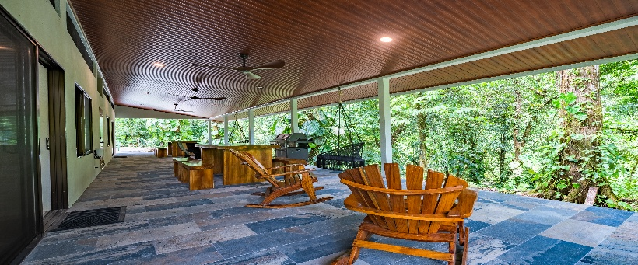
Please change the picture of the front of the house to the picture of the porch below. Let me know if you need it
Change “Coffee” to “Drinks”

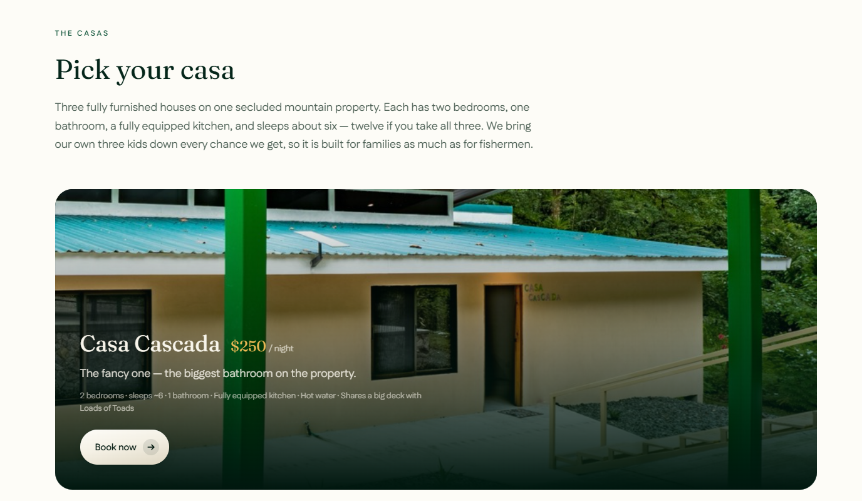
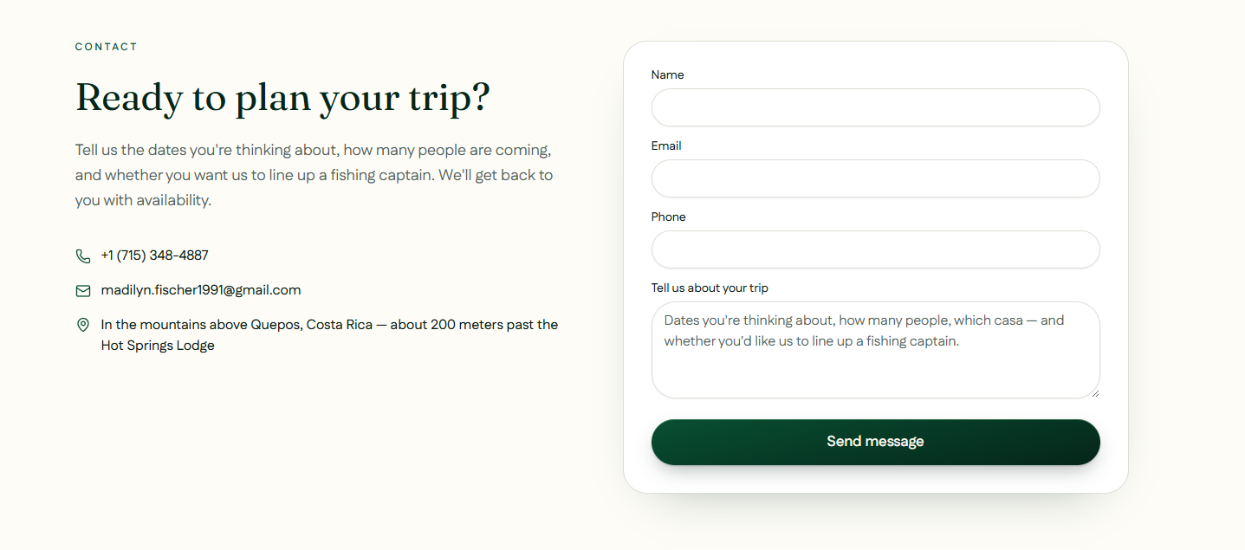
Please change my email to madi@fischertropitel.com
And please add 715-573-5576 & 715-581-7713 to the phone numbers if possible
Can we add more photos of each house here like a slide show?

